Lecture 7
Increasing of Phosphate Fertilizers Efficiency
Introduction
Phosphorous is one of the major nutrients, as all plants need it in large quantities for its role in the basic biological processes inside the plant (photosynthesis and respiration), formation and division of cells, its contribution to the synthesis and synthesis of energy-processing compounds (ATP, ADP), in addition to its entry into the synthesis of Cell membranes and nucleic acids (DNA, RNA) .
The total content of phosphorous in soil in general ranges between 200-5000, with an average rate of 600 mg kg⁻¹ soil .As for its available content, it is very limited compared to its total content. It was found that it does not exceed 0.01% of its total content, and its available content in soil generally reaches 0.03 mg kg⁻¹ soil.
Its availability in soil is affected by many factors,:-
1:Soil pH
2: Carbonate minerals
3: Type and content of clay
4:Soil texture
5:Organic matter content
6: Soil s salinity
80% of the Iraqi soils, especially the sedimentary plains, have a carbonate minerals content (50-500 g.kg⁻¹) and these soils have a (pH > 7.4) and the predominant ions are calcium and magnesium.
The lack of availability of phosphorus in soils, especially in calcareous soils, is due to its adsorption and precipitation by carbonate minerals.
Because of the plant's great need of this element, which requires the addition of phosphate fertilizers to provide the appropriate level of phosphorus in soil and to obtain optimal production.
Many phosphate fertilizers, single and compound, have been produced with different physical and chemical properties in terms of solubility, pH, color, size and others. The efficiency of these fertilizers and their behavior in soil varies with the different nature and composition of the soil and the characteristics of the fertilizer itself.

There are several technologies and strategies to increase the efficiency of phosphate fertilizers in soils, including the following directions:
First: Strategies for efficient utilization of native soil-P
1. Using crops suitable for phosphorous and their varieties
2. The use of root fungi or mycorrhizae
3. The use of phosphate-dissolving microorganisms
Second: Strategies for efficient utilization of fertilizer phosphate
Third: Strategies for the direct use of rock phosphate

First: Strategies for efficient utilization of native soil-P
1. Using crops suitable for phosphorous and their varieties
Crops differ in their needs of phosphorous, and their planting dates and the nature of root spread have an effect on the efficiency of phosphate fertilizer.
There are roots capable of absorbing dissolved phosphorous from soil solutions. There are roots that are able to dissolve some phosphorous compounds, making it available for absorption by them. There are also plants whose roots are capable of absorbing roots by mass diffusion, in addition to the presence of some plants with deep roots that have the ability to absorb original phosphorus in the soil.
Plant roots absorb phosphorous in the form of orthophosphate ions (H₂PO₄⁻,HPO₄⁻²), and most soils absorb phosphorous in the form of H₂PO₄⁻ except for calcareous and alkaline soils, it is absorbed in the form of HPO₄⁻². Plant roots absorb small amounts of phosphorous from the soil solution because xylem contains 100-1000 times more phosphorous than the soil solution (Mengel and Kirkby, 1982). The transport of phosphorous through the cells of the root cell wall varies from one species to another and from one type to another.
length of root has an effect on the amount of phosphorous absorbed from the soil per unit area
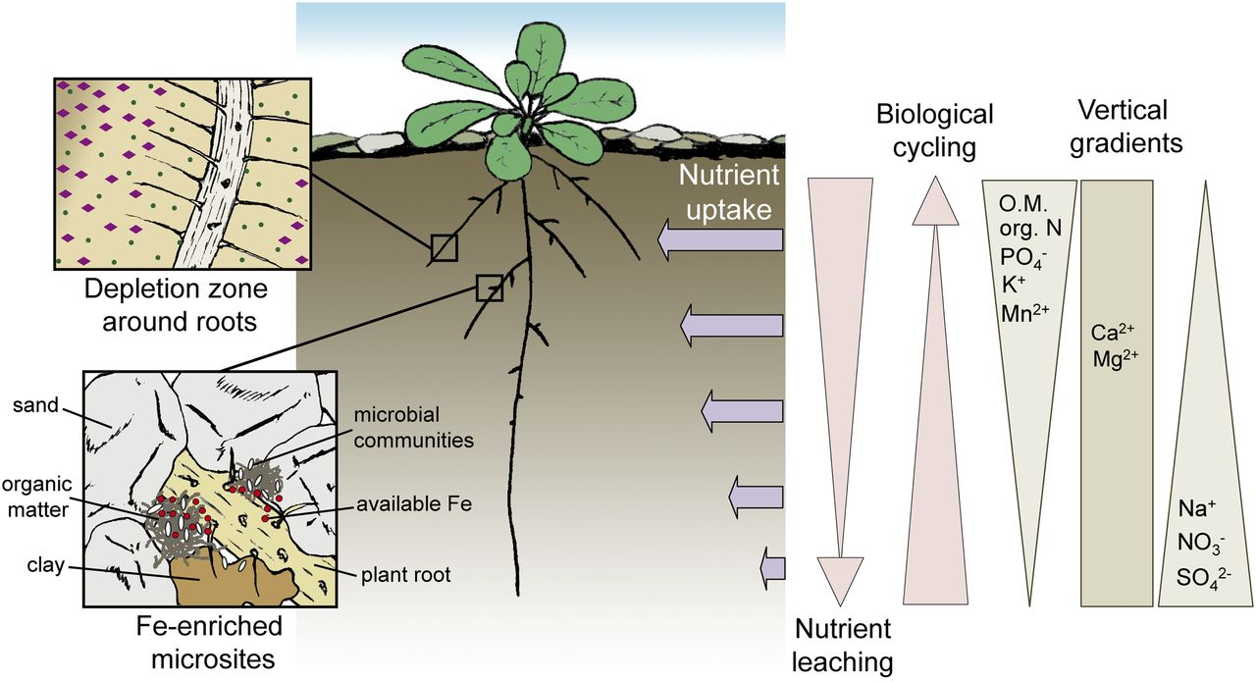
Figure 1: Distribution of nutrients absorption within root zone of plant
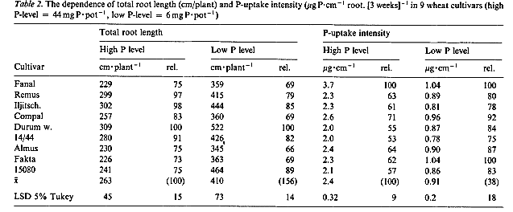
2. The use of root fungi or mycorrhizae
Mycorrhiza is a Greek word derived from the word myco, meaning fungus, and rhiza, meaning roots fungus.
First who named this was the Dutch scientist Frank in 1885, then the concept of this term developed to describe the common symbiotic relationship that occurs between the roots of high-end plants with non-pathogenic soil fungi, because in this relationship there is an exchange between fungi and plants for some compounds and elements that are used in growth and reproduction For both partners, mycorrhizal fungi belong to several fungal phyla: Glomeromycota, Basidiomycota and Ascomycota.
Mycorrhizal fungi spread in all types of soil and in a wide range of ecosystem extending to include desert and tropical environment, forest environment and aquatic environments. About the possibility of the formation of Mycorrhiza colonies in dry soils, and also grows in hydroponic farms and waterlogged soils.
Mycorrhizal fungi establish a symbiotic relationship with plants. It is divided into two main types, the ectomycorrhizae, in which the fungus does not penetrate the cell wall of the roots of plants. The second type is the endomycorrhizae that penetrate the cell wall of plant roots. The second group is very important in biological fertilization, and it is called Arbuscular mycorrhizae in reference to the formation of its distinctive branches inside the cells of the roots of plants.
Mycorrhiza has an important and significant role in providing plants with macronutrients such as phosphorous, nitrogen, sulfur and some minor elements such as copper and zinc. infected with mycorrhizal fungus.
The use of mycorrhiza has an effect in increasing the efficiency of the roots in extracting phosphorous from the soil, whether it is original or added in the form of fertilizer.
There are three mechanisms of Vesicular Arbuscular Mycorrhizae (VAM) in increasing the efficiency of phosphorous use by plants: -
1. Improvement of physical properties of soil
Mycorrhizal fungus has several important functions for plants, soil, environment or other beneficial microorganisms that live with them in the soil. The soil among them, it added, and 80% of this substance works on the adhesion of the fungal yarn to the soil particles. It was also found that there are other compounds secreted by Mycorrhizae that improve the composition of the soil, such as the Polysaccharides compound, which helps to stick the soil particles together, which increases its ability to retain water. .
The mycorrhizal fungi are intertwined with the roots of the host and form a complex structure that works to hold the soil granules, and the fine soil granules are collected by the action of the organic compounds secreted by the fungal hyphae and roots. Soil is a suitable environment for the growth of other microorganisms.
2.Modifying the chemical properties of the rhizospher
Through the secretion of some organic compounds and adjusting the value of soil pH . Organic compounds resulting from mycorrhiza also act as chelating agents with phosphorous, which are slow-release fertilizers for phosphorous.
The absorption of phosphorous by the fungus is carried out by several mechanisms, including the secretion of the enzyme Phosphatase by the fungus hyphae, which dissolves the organic phosphorous and converts it into forms available for absorption by plant, as well as the secretion of acids and organic compounds that chelate elements of calcium, iron and aluminum, leaving phosphorus element dissolved in a soil solution .Mycorrhizal fungi also increase the activity of phosphate-dissolving bacteria as a result of a mutually beneficial relationship. This in turn leads to an increase in the concentration of soluble phosphorous in soil solution.
The excessive growth of VAM hyphates reduces the distance between phosphorus and its inhibitors (iron oxides, aluminum and calcium carbonate), which increases its availability in the soil. The radii of the small hyphae, which are about 2-4 µm, compared to the root hairs, are 7-10 µm. Hyphates also increase the surface area to absorb phosphorous and enter the pores and spaces between soil particles, which plant roots can enter.
In general, the use of these microorganisms (VAM) should be under controlled conditions of competition between them and plant roots for the original phosphorus in the soil.
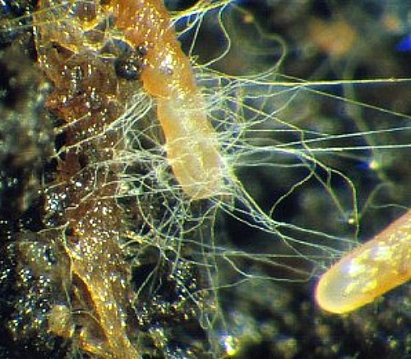
Fig.2: Mycorrhiza fungi on wheat root plant
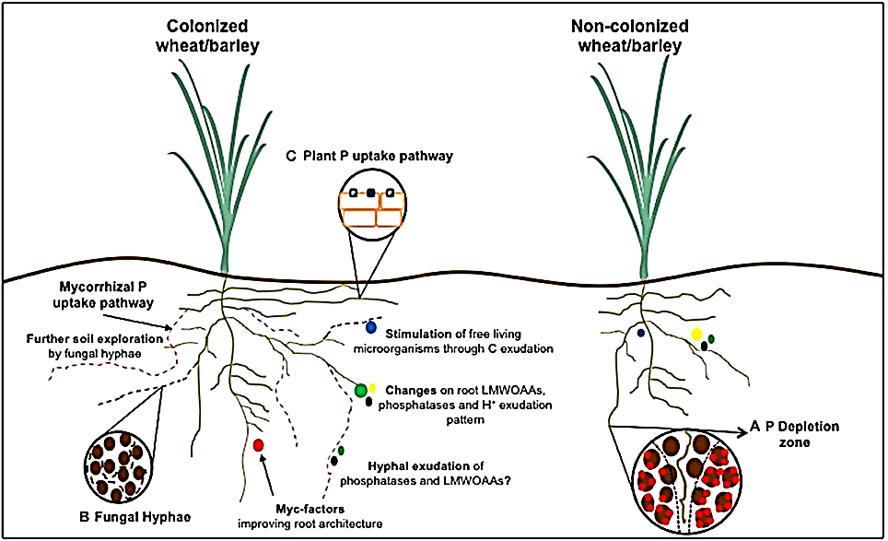
3.Use of phosphate-dissolving microorganisms
There are many microorganisms endemic to the soil, which play an important role in plant growth and development. Phosphate-dissolving microorganisms have been widely used to increase the availability of the original soil phosphorous or to increase the efficiency of using added phosphorous to achieve the highest benefit for the plant. This method is one of the types of Biofertilization that was used in the past by Cooper (1959) in Russia to increase the availability of the original phosphorous in soil.
Microorganisms vary in the rhizosphere, which have the ability to dissolve phosphorous and convert it to available. Several types of soil fungi have been identified that have the ability to convert phosphorous from its unavailable form into available forms in soil, including Penicillum spp. and spp. Mucor and Aspergillus sp. There are types of Trichoderma spp which are phosphate-dissolving fungi.
It was also found that there are species of bacteria that increase the availability of phosphorous in the soil, they are Acinetobacter, Arthrobacter, Azospirillum, Bacillus and Burkholderia.Enterobacter, Erwinia, Flavobacterium, Paenibacillus,Pseudomonas, Rhizobium, and Serratia.
Phosphate-dissolving bacteria constitute 1-50% of the total micro-organisms in the soil, which have a major role in dissolving phosphate. As there are many bacteria that have the ability to dissolve tri-calcium phosphate and convert it into available for absorption by the plant. The Bacillus genus is one of the important phosphate-dissolving bacteria, as it represents 50-60% of the phosphate-dissolving microbes. Where these bacteria work on the mineralization of organic phosphorous, especially in soils rich in organic matter. It was found that 50% of the crops grown in those soils treated with bacteria have increased production by 20%. This effect was more especially in neutral and alkaline soils with high organic matter content.
Soil microorganisms can dissolve phosphate minerals by releasing some of the bio-metabolic products such as organic acids, hydroxyl and carboxylic groups of chelating cations, which change form of phosphate to dissolved forms. The mechanisms of action of microorganisms in dissolving phosphate minerals vary, including the production of organic acid and the giving of protons. Mineral acids such as hydrochloric acid dissolve phosphate compounds, but with less efficiency than organic acids at the same degree of soil pH.. The roots also secrete organic acids, which release a molecule of phosphorous.
The main mechanisms of liberating phosphorous from its mineral compounds by soil microorganisms include the chelation, complexes or dissolution of mineral compounds (organic acid ions, chelation, proton, hydroxide and carbon dioxide), secretion of extracellular enzymes (phosphorous mineralization) and liberation of organic phosphorous through the breakdown or dissolution of organic matter.
The presence of microorganisms with organic matter in the soil increases the activity of organisms and supplies them with energy elements from carbon, which is positively reflected on the increase in the availability of phosphorus in the soil and the productivity of plants.
Table 3:Effect of different fertilizer treatments on potato yield and some of its components.
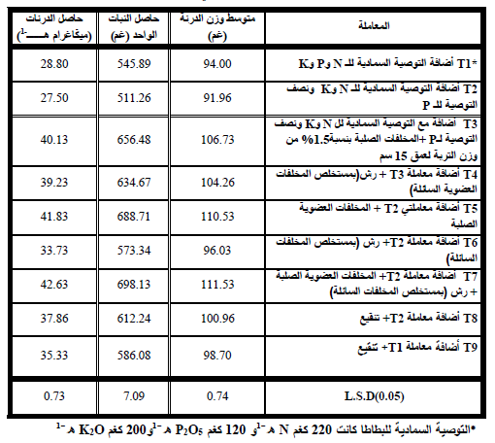
Fungal bio-fertilizers are considered as bio-fertilizers, and they are one of the modern techniques to limit the excessive use of chemical fertilizers, as they are of economic importance in the field of agriculture by increasing the absorption of some nutrients such as phosphorous, nitrogen and micro-elements or through their ability to decompose organic waste or in the secretion of some growth regulators. Its importance in biological control
Second: Strategies for efficient utilization of fertilizer phosphate
Because of the rapid interaction of soluble phosphorous in the soil solution with the cations (Fe²⁺, Al³⁺, Ca²⁺) in the soil solution or the cations and anions present on the surface of clay colloids and organic matter, which impedes and restricts the movement of phosphorus to the surface of the roots and its absorption, in addition to its precipitation and adsorption by soil colloids . Phosphate Fertilizer Placement Methods
Fertilizers are usually added in several ways, but they achieve three main goals:
1. Let the element available for absorption by the plant
2. Reduce fertilizer loss
3. Ease of adding and handling fertilizer
Therefore, several methods have been followed to increase the efficiency of phosphate fertilizers, including the following: -
- Because the phosphorous element has very little movement and is very limited in the soil, so the fertilizer must be placed in the root area
- Phosphorous fertilizer is added superficially to crops with shallow roots and does not contain phosphorous-fixing materials such as calcium carbonate, iron and aluminum oxides.
- The addition of phosphorous fertilizer is not preferable to mixing with soils with a high content of calcium carbonate, because it will cause the adsorption and precipitation of phosphorus due to the high chance of phosphorous contact with calcium and formation of calcium phosphate compounds with low solubility.
- It is preferable to add fertilizer in an unfair manner, especially in soils with high fixing materials (calcium carbonate), such as Iraqi soils
- There are few recommendations about adding phosphate fertilizer in the form of foliar on the plant, but most phosphate fertilizers are added to the soil before sowing
- The addition of phosphate fertilizers in the form of row gives better results than broadcasting, as the latter is considered less beneficial to the plant
- It is not preferable to mix fertilizer with seeds for fear of the effect of salinity on the seed embryo, especially in soils with a low cation exchange capacity (CEC) less than 7 cmmol kg⁻¹ kg soil
Phosphorus Fertilizer Timing (Time of Application)
The date of adding phosphate fertilizer does not have a clear effect compared to the dates of adding nitrogen fertilizer. But in general, the presence of phosphorous for a long time with the components of the soil increases the adsorption and precipitation of phosphorous. Therefore, the most important recommendations about the technique of adding phosphate fertilizers can be summarized as follows: -
- It is preferable to add phosphate fertilizer in crops and annual plants before planting and in row, and it is not preferable to add it in broadcasting manner.
- The phosphorous element does not suffer from the leaching process as it does the nitrogen element, so phosphorous can be added with the presence of rain, but not in the case of frost.
- Phosphorous loss can occur in the event of soil erosion, so it is not preferable to add it on those dates
- The best absorption of phosphorous is in the spring time
Both the dates and methods of adding phosphate fertilizers depend on the nature, characteristics and composition of the fertilizer, soil characteristics, the type of crop, the nature of its root spread and its growth period.
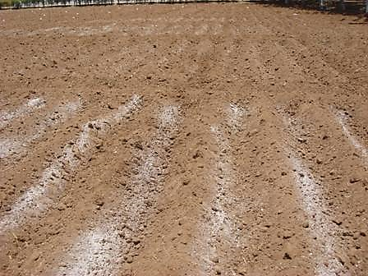
Fig. 3: Application of phosphorus fertilizer in row method
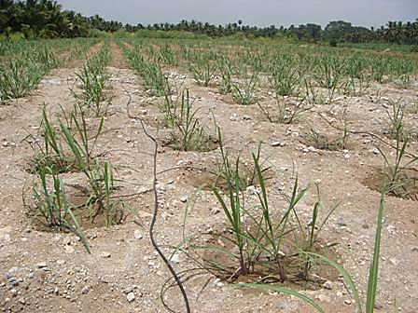
Fig.4: Application of phosphorus fertilizer in fertigation method

Third: Strategies for the direct use of rock phosphate
phosphate rock In Iraq, in western Iraq, in Akashat area in Al-Qaim district in Anbar Governorate, and its extensions end in the Syrian-Jordanian lands. Phosphate rock is a mineral sedimentary rock that is predominant in it Fluorapatite Ca₁₀F₂(PO₄) ₆.XCaCO₃, the Iraqi phosphate rock production in the year 1999 About 415 thousand tons, equivalent to 0.3% of global production (Mew, 2000)
Apatite is classified into three groups: calcium apatite Ca₃(PO₄)₂.CaX₂ or Ca₁₀(PO4)₆X₂, manganese apatite Mn₃(PO₄)₂.CaX₂ and strontium apatite Sr₃(PO₄)₂.CaX₂. The calcium apatite group is one of the most important apatite groups, which includes Fluoropeptite, hydroxyapatite, chloropeptite, and carbonate apatite, and these species are not found alone. The most common of them is fluoropeptite mixed with chloroapatite. Most of the apatite rocks are in the form of sediments called phosphorites, which are characterized by being colloidal and often combined with carbonates.
Phosphate rocks are found in nature in one of the following forms:
- Phosphate rocks of sedimentary origin constitute 80% of the global sediments in them, and the proportion of phosphorous pentoxide in them ranges from 20% to 30%, and they are originally granular marine sediments, such as those in Egypt, Jordan, northern Saudi Arabia, North African countries and Iraq.
- Phosphate rocks of igneous origin. These rocks are a product of nepheline syenite (igneous rock), carbonate rocks and pyroxenes that contain a high percentage of phosphate minerals such as apatite, such as sediments found in some regions of Russia.
- Sediments called guano, which are sediments resulting from the remnants of seabirds over limestone, such as the sediments found on the island of Nyora in the Pacific Ocean.
Phosphate rocks are found in all continents of the world, where it is used as a raw material in the manufacture of phosphate fertilizers, and can be used in the form of mineral phosphorous fertilizers when applied directly to the soil. Direct application of rock phosphate to the soil increases crop yield and increases phosphorous levels in the soil
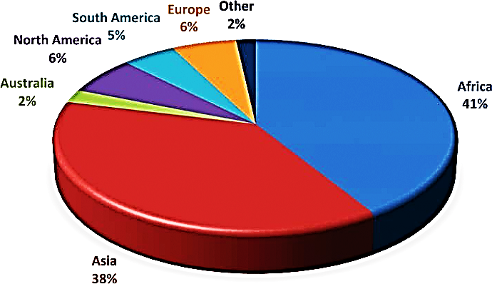
The first phosphate fertilizer widely used in Europe during the first decade of the nineteenth century was bone flour. In 1830, the bones began to be treated with sulfuric acid, as the bones turned into a thick and viscous liquid. This product was distributed to farmers, and sometimes potassium salts, ammonium sulfate or sodium nitrate were added to it. Thus, the first liquid and viscous chemical fertilizer was produced and presented. In 1840, phosphate rocks began to be treated with sulfuric acid, and the fertilizer gave good and effective results. This fertilizer was called superphosphate. In 1842, the production of the first successful commercial phosphate fertilizer began by Lawes in England, followed by others, so that in 1853 there were 14 factories in England alone.
Ca₁₀(PO₄)₂F₂ + 7H₂SO₄ + 3H₂O 3Ca(H₂PO₄)_{2.}H₂O +7CaSO₄ + 2HF
This fertilizer contains 7- 9.5% phosphorous and about 90% of its phosphate content is soluble in water and contains gypsum at a rate ranging between 8-10%. Therefore, it is preferable to add it to poor sulfur soils and soda soils.
The history of producing concentrated phosphate fertilizer or triple super phosphate fertilizer correlates with the production of phosphoric acid. In 1870, the first commercial production in Germany of concentrated or triple superphosphate fertilizer began. Where the goal was to benefit from phosphate rock in the manufacture of phosphate fertilizers. This fertilizer contains 19-23% phosphorous and about 95-98% of it is soluble in water.
Phosphate rock was used directly in acidic soils with a (pH) less than 5.5 to 6.0, but it is required that the phosphate rock be soft to ensure its dissolution and the release of phosphorous from it. It is also preferable to add phosphate rock in doses to ensure the liberation and dissolution of phosphorous. Plants differ in their ability to benefit from phosphate rock. Therefore, it is preferable to use it for plants with roots with a high cation exchange capacity (CEC).

To increase in the efficiency of phosphate rock can be summarized in the following points:-
1. Mixing phosphate rock with soluble phosphate fertilizer
2. Mixing phosphate rock with mineral sulfur or sulfur-containing compounds, because when sulfur is oxidized to sulfuric acid, the acid dissolves phosphate rock and makes it available for absorption by the plant. The oxidation process is carried out by the bacteria Thibacillus thioxidans and Thiobacillus thioparus. Factors including soil organic matter content, soil pH, soil texture, temperature and moisture content.
3. The use of phosphate solubilizing microorganisms, which are found in most soils, but their preparation depends on the soil’s organic matter content, temperature, moisture content, soil texture, the growth of the cultivated crop and others.
4. There are other methods that include treating phosphate rock with materials or fertilizers, which are: -
- Mixing phosphate rock with nitrogen fertilizers in the form of band or in the form of granules or mixing
- Mixing phosphate rock with organic matter
- Cultivation of crops with fine and smooth roots (such as legumes) that decrease soil pH value in the rhizosphere and reduce the calcium concentration in the uptake zone.

